

NORTHWEST

TERRITORIAL

DAYS

August 13th -15th, 2025

North Battleford Exhibition Park

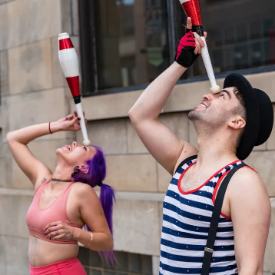

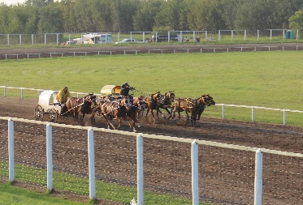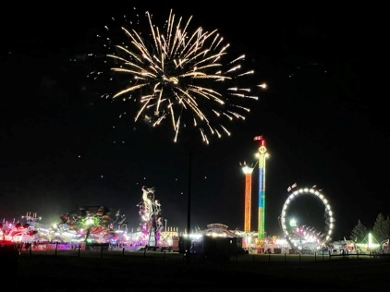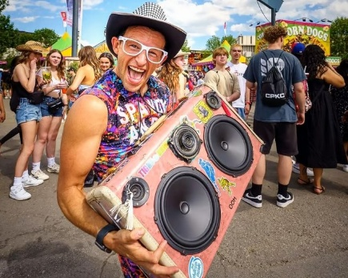

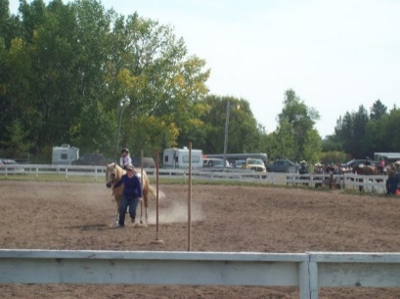



** @ THE LITTLE RED BARN – 1 to 8PM**

**Nevada Sales** Open until 10 PM **@** 4-Plex

**Prize Bingo** Open until 11 PM @ Behind Agrivilla

**SCHEDULE OF EVENTS**

**CHARIOT & CHUCKWAGONS**

Grandstand

**WEDNESDAY**

*Chariots 3 PM*

*Chuckwagons 6 PM*

**THURSDAY**

*Chariots 3 PM*

*Chuckwagons 6 PM*

**FRIDAY**

*Chariots 2 PM*

*Chuckwagons 5 PM*

**LIGHT HORSE SCHEDULE**

All events at the big ring

**THURSDAY – 9 AM**

*Light Horse - Jr. & Sr. Performance*

**FRIDAY – 9 AM**

*Light Horse - Jr. & Sr. Performance*

**Pony Rides, Bouncy Castles, Petting Zoo**

**MIDWAY & COMMERCIAL EXHIBITS OPEN AT NOON**

With extreme heat we are happy to offer everyone shelter & shade from the heat & sun.

Table & chairs will be set up in the AGRIPLEX for your comfort!!

**NORTHWEST TERRITORIAL DAYS DAILY ENTERTAINMENT LINEUP**



*LOCATED IN FRONT OF THE AGRIPLEX*

**Kids Day**

**Free Gate Admission 12 & under**

**Noon to 6 PM**

**WEDNESDAY AUGUST 13TH**

1 PM Spandy Andy – Dance Party

3 PM Jojo’s Magic Circus – Circus Play Shop

4 PM Demmi Dupri – Magic Balloon Show

5 PM Spandy Andy – Spandy Vs. Giant Balloon

6 PM Demmi Dupri – Circus Play Shop

7 PM Jojo’s Magic Circus – Magic/Circus Show

8 PM Spandy Andy – Dance Party

**THURSDAY AUGUST 14TH**

1 PM Demmi Dupri – Circus Play Shop

3 PM Jordan Sabo – Magic & Juggling Sow

4 PM Demmi Dupri – Magic Balloon Show

5 PM Spandy Andy – Spandy Vs. Giant Balloon

6 PM Demmi Dupri – Circus Play Shop

**FRIDAY AUGUST 15TH**

2 PM Demmi Dupri – Circus Play Shop

3 PM Spandy Andy – Spandy Vs. Giant Balloon

5 PM Demmi Dupri – Magic Balloon Show

6 PM Jordan Sabo – Magic & Juggling Sow

7 PM Demmi Dupri – Circus Play Shop

*\*\*All Performances and Times Subject to Change\*\**



**FIREWORKS FRIDAY AT DUSK**

